Developing Egypt Via Better Science and Technology

Education and Training

By
Dr. Mahmoud Fawzy Wagdy
Professor of Electrical Engineering
California State University,
Long Beach, CA 90840, USA
Tel: (562) 985-5110 & Email: wagdy@csulb.edu

I. ABSTRACT

Science and technology should play a pivotal role in the industry- based economic growth of Egypt in order to overcome its difficulties and raise the standard of living of people in the 21st century. To that end, the industrial production should improve in terms of its (1) breadth, (2) diversification, and (3) depth [1]. In this paper, the author highlights a number of educational and training issues that significantly affect the achievement of these goals.

Increasing the production volume (breadth) requires more laborers, technicians, analysts, designers, scientists, and engineers; this requires reducing illiteracy, changing curricula, changing the student mix at various educational stages, and replacing the science-humanity split at the high-school level by a more balanced educational system to increase the number of students specializing in science and technology.

Diversification of the industrial production requires diversification of courses at all educational levels including vocational education, industry-school partnerships, multidisciplinary university research, and a wider range of sub-specialty knowledge and training.

Having more depth in the industrial production, and hence more “added value”, requires embracing the concept of project work throughout all educational stages, bridging the gap between supply and demand, stronger state support for R&D (research and development), aligning the interests of university faculty, R&D centers, and industrial corporations, and more targeted collaboration with technologically-advanced countries and expatriate Egyptians. R&D should be regarded as a national project for the advancement of Egypt; this includes design, development, research, technology transfer, and reverse engineering [1].

II. INCREASING PRODUCTION VOLUME VIA INCREASING THE
NUMBER OF SCIENCE/TECHNOLOGY ORIENTED STUDENTS

1. Educational Attainment and Enrollment in Egypt:

Table 1 shown below is extracted from Egyptian Government data about education [2].

Education Category | No. of Students  Registered | Year | Remark
All Educational Stages | 18,820,000 | 2004
Pre-University (Including Azhar) | 16,896,000 | 2004
Pre-University  (Private) | 1,170,000 | 2004 | 7% of Total
Illiteracy | 28.59% | 2004 | Rate
Illiteracy (Males) | 17.00% | 2003 | Rate
Illiteracy (Females) | 40.70% | 2003 | Rate
Primary Education | 7, 214,826 | 2004
Preparatory Education | 4,183,587 | 2004
General Secondary Education | 1,272,650 | 2004
Intermediate Institutes  (Public) | 135,086 | 2004
Intermediate Institutes  (Private) | 39,693 | 2004
Secondary Industrial Education | 1,048,091 | 2004
Secondary Commercial Education | 882,916 | 2004
Secondary Agricultural Education | 268,473 | 2004
Higher and University Education (Including Azhar) | 2,023,177 | 2004
Private High Institutions | 320,692 | 2004
Private Universities | 36,834 | 2004
Labor University | 41,748 | 2004
University Graduates (State Universities) | 226,813 | 2003 | Number of Graduates
M.S. Programs | 36,067 | 2003
Ph.D. Programs | 13,869 | 2003

Table 1. Results Extracted from Research on Education in Egypt [2]

Table 1 reveals the following:
1.1. Illiteracy Rate:
Illiteracy rate is still high (28.59% overall, 17% for males, and 40.7% for females). Needless to say, illiterates are not qualified to work in industrially-related activities. More work needs to be devoted to the illiteracy problem via some innovative methods, e.g. utilizing the unemployed graduates in a better way !

1.2. Educational Attainment:
The educational attainment of students in pre-university education shows an inadequate distribution along the pipeline, as shown in Fig. 1 below.

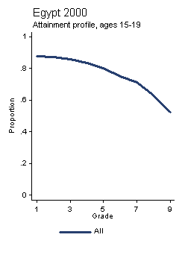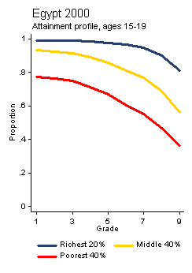

Fig. 1. Attainment Profiles
for School Students in Egypt [3]

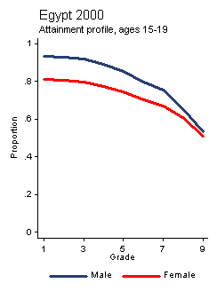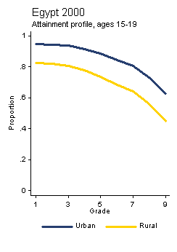
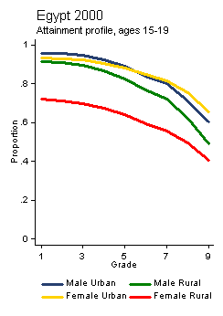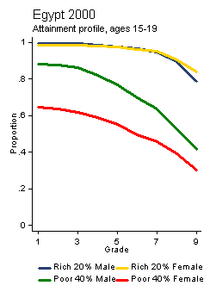
Fig. 1 (Continued): Attainment Profiles
for School Students in Egypt [3]

The educational attainment across a sample of developing countries is shown below
in Table 2. The table [4] reveals that the average years of schooling of Egyptians is
7.4 (males) and 4.9 (females). The combined average years of schooling is 6.2 years
as of 2001 [5].

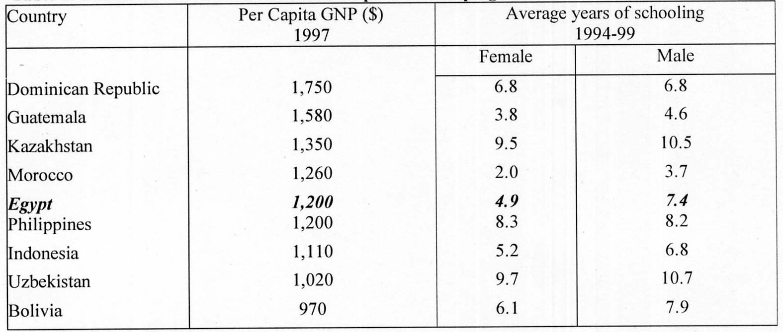

Table 2. Educational Attainment Across
a Sample of Developing Countries [4]

1.3. Hazardous Exit:
There is a hazardous exit among students during all years, which increases significantly at the end of grade 11, as shown in Fig. 2.

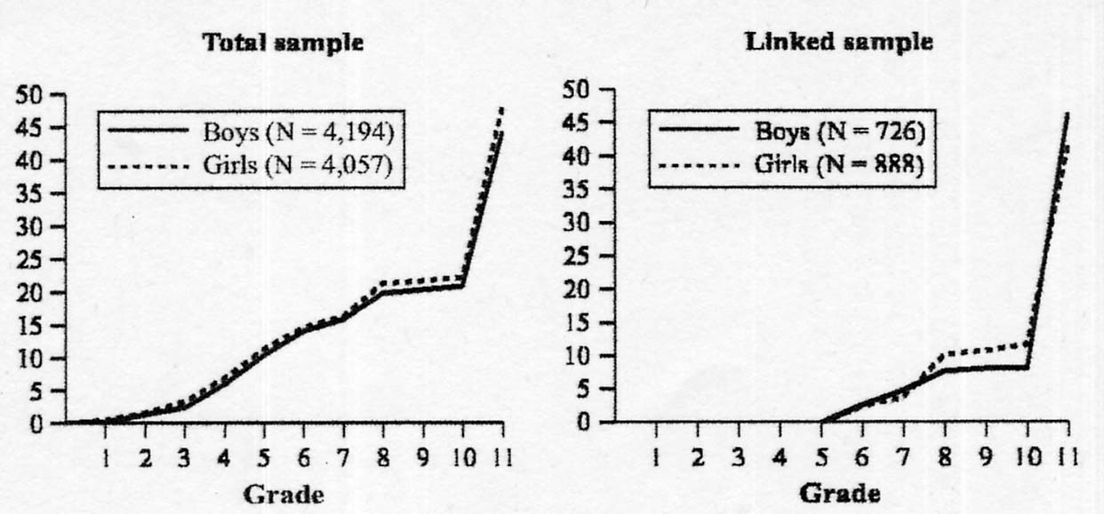

Fig. 2. Cumulative Percentage of Adolescents
who have Left School, by Grade and Sex [6]

The question “how the quality of preparatory school affects these educational
pathways” becomes increasingly salient. The author believes that curricular changes
are needed to reduce exit at the 11th grade which marks the end of secondary
education.

1.4. Limited Graduate-Level Enrollment:
The phenomenon of an awkwardly-looking pyramid, i.e. one with a wide base and a narrow top, is repeated at the after-university level. The number of those enrolled in M.S. and Ph.D. programs is relatively small !

1.5. Imbalance Between Industrial and Commercial Education:
The number of students in commercial secondary education is relatively high (882,916), which should be reduced while the number of students in industrial secondary education (1,048,091) should be increased.

Balancing these numbers will increase the ratio of laborers and technicians who can work in industry and hence increase the volume of the Egyptian production. Table 3 shows student enrollments in secondary education [7].

Secondary Edu. Program | 1985-86 |  | 1991-92 |  | 1995-96 |  | 1999-00
Secondary Edu. Program | Enrollment | % | Enrollment | % | Enrollment | % | Enrollment | %
1. General | 173,000 | 35.4 | 174,273 | 30.6 | 270,198 | 32.7 | 353,858 | 35.0
2. Technical | 295,600 | 60.6 | 394,717 | 69.4 | 556,014 | 67.3 | 656,167 | 65.0
2.1 Industrial | 106,400 | 21.8 | 177,932 | 31.3 | 251,111 | 30.4 | 293,187 | 29.1
2.2 Commercial | 151,200 | 31.0 | 168,421 | 29.6 | 248,071 | 30. 0 | 297,212 | 29.4
2.3 Agricultural | 38,000 | 7.8 | 48,364 | 8.5 | 56,832 | 6.9 | 65,768 | 6.5
3. Teacher | 19,400 | 4.0 | … | … | … | … | … | …
Total | 488,000 | … | 568,990 | 63.0* | 826,212 | 96.7* | 1,010,025 | 96.7*

Table 3. Student Enrollments in Secondary Education [7]

Finally, one solution to the above-mentioned awkward-pyramid-problem in all educational stages in Egypt is by changing the educational syllabi to attract students from all student categories and provide more evenly distributed amounts of knowledge and training over the years of education !

2. Enrollments in Science Versus Humanities Sections:

2.1. The Problem:
In the author’s opinion, the enrollment imbalance between science (ELMY) and humanities or literature (ADABY) in Egypt, hurts in two ways:
- It is a sign of under-development.
- It also contributes to under-development.

In an industrialized society, science and technology attract more students than do humanities.

In 2004, about 850,000 students entered the examination for the General Secondary Education; the students of humanities constituted 71.9% versus 28.1% for the students of science [8]. Among those students who originally enrolled in the scientific section, 52% transferred to the humanities section [8].

Effective the academic year 1999/2000, the imbalance trend caused a 34.5% reduction in the number of students enrolled in scientific colleges; this reduction continued and the percentage became 31.9% last year [9]; the total number of students admitted in humanity colleges was 164,665 while those admitted to scientific were only 77,182.

To appreciate the size of the problem, 80% of students in advanced countries join science whereas humanities constitutes only 20% [10]. The imbalance phenomenon in Egypt is dangerous as it limits the ability of high-school graduates to compete in the international markets.

2.2. Reasons of the Problem:
There are many reasons behind this undesirable phenomenon [11]:
(1) There is a difference between the minimum scores required by the science and
humanity sections to enter the same college. For example last year’s difference was
4.9% for the Colleges of Commerce, 9.1% for the Colleges of Literature, and 14.7%
for the Colleges of Law.
(2) The score inflation in the science section is significantly higher than that of the
humanities section. In 2003, those who scored more than 90% of science students
were 55,000, compared to only 10,000 of humanity students.
(3) Science subjects are more difficult than humanity subjects.
(4) Employment opportunities for science students are not sufficient, e.g. the graduates of
science, engineering, and agriculture.
(5) Cost of study in science courses is higher than that of humanity courses.
(6) Canceling the rules that gave the option to students to repeat exams and improve their
scores. In the late 90’s, before that change went into effect, science constituted 70%
versus 30% for humanities [10].

2.3. Remedies by the Supreme Council of Universities:
The SCU committee [11] proposed the following remedies:
(1) Encouraging students to study science via improving curricula and exams to develop
their capabilities.
(2) Simplifying scientific subjects and distributing them on the first and second stages.
(3) Studying the option of having two sections only (science and humanities) instead of
science, mathematics, science/humanities, and humanities.
(4) Promoting science and technology in the media.

2.4. Author’s Proposed Solution:
The author finds that the remedies proposed by the Supreme Council of Universities are not sufficient to solve the problem. The author proposes a more comprehensive solution by adopting some of the concepts employed in the U.S., namely avoiding the split of secondary education students among science and humanities options. The present system will be replaced by the following system:
(1) Students entering all colleges take a number of common core courses.
(2) Each student will have to take a number of elective courses required by his preferred
college of choice.
A deep study should be undertaken before the change goes into effect. This study should include existing schools, labs, and teacher qualifications, etc.

III. INCREASING PRODUCTION DIVERSITY VIA DIVERSIFYING
SCIENCE AND TECHNOLOGY EDUCATION AND TRAINING

Diversity of industrial production is a major factor for increasing the exports of a country [1]. To increase “Egypt’s ability to export”, the concept of “diversity” should be implemented at all educational levels as well as among practicing professionals, designers, and engineers. The author believes that the following concrete steps are prerequisites for the advancement of Egypt:

1. Diversification of Courses:

This diversification broadens students’ horizons and enhances their abilities to have diversified products after graduation.

1.1. Consequences of Lack of Diversification:
A rigid set of courses which is mandatory for all students results in a multitude of students with similar capabilities, which limits their horizons and reflects badly on their initiatives to start new businesses.

1.2. Benefits of Diversification:
Diversification of student backgrounds enrolled in the same program helps them create sub-specialties, which favorably reflects on their abilities to start new businesses. The implementation of the concept of diversification requires always having a set of mandatory common core courses as well as many elective courses at all levels from primary schooling through university. An example of a diversified program of study was demonstrated by the AUC (American University in Cairo) liberal arts program [12]; this program is one of the most important strengths at the AUC.

2. Steering Some K-12 Courses By Industry:

Some US companies steer new K-12 courses [13]; a concept that could be implemented in Egypt. This includes business-school partnerships for supply of equipment, teacher training internships, apprenticeship programs, etc. US companies participating in these partnerships deal with the fact that half of US students never attend college and about three quarters of them do not complete 4-year colleges [13].

3. Diversification of Vocational Education:

Table 4 shows student enrollments in secondary education by program.

Tech. Sec. Program | 1991-92 |  | 1995-96 |  | 1999-00
Tech. Sec. Program | Enrollment | % | Enrollment | % | Enrollment | %
Agricultural | 48,364 | 12.2 | 56,832 | 10.2 | 65,768 | 10.0
Industrial | 177,932 | 45.1 | 251,111 | 45.2 | 293,187 | 44.7
Commercial | 168,421 | 42.7 | 248,071 | 44.6 | 297,212 | 45.3
Total | 394,717 | 100.0 | 556,014 | 100.0 | 656 167 | 100.0
Table 4. Technical Secondary School Enrollment, By Program [7]
The author believes that the industrial program enrollment increase at the expense of a decrease in the commercial program enrollment.
3.1. Industrial Education:
The new industrial program enrollment needs more diversification. As it stands, there are about 20 production and construction specialties; there is a need to increase these specialties as well as create new sub-specialties.

3.2. The Mubarak/ Kohl Program [14]:
This program is considered a step in the forward direction. A survey showed some urgent need for skilled mechanics, welders, plumbers, industrial electronic technicians, electricians to maintain and repair modern factory equipment, textile industry, and instructional media. However, the author believes there is a need for more sub-specialized training by the Germans in Egypt.

4. Multidisciplinary Research Centers at Universities:

The concept of virtual multidisciplinary research centers has been adopted by Israel [15]. These centers are funded by faculty members from their own research contracts. When the research subject is exhausted, the virtual center is dissolved. This concept helps universities avoid the establishment of permanent research institutes which cannot be easily dismantled when their subject is exhausted; also the university can quickly respond to shifting directions in research. The Technion, Israel’s senior technological research university, has many specialized virtual multidisciplinary centers [15].

5. Industry Technology Centers [16]:

5.1. The Announced Goal:
The Ministry of Industry and Technological Development has a plan for building 15 technology centers for: Textile and Apparel, Food Industry, Leather Industry, Electronics Industry, Building Materials Industry, Marble and Granite, Metal Industries, Chemical Industries, Typical Industries, Environmental Technology, Lumber and Furniture, Medicine Industries, Information Technology, Minerals Industries, and Engineering Industries. The idea of establishing these centers is considered a step in the forward direction.

5.2. The Present Situation:
Only the following technology centers have been established so far:
- Textile Industries.
- Leather Industries.
- Food Industries.
More technology centers need to be built to enhance the industrial diversification at the professional engineering levels.

IV. INCREASING PRODUCTION ADDED VALUE VIA INCORPORATING R&D AT ALL EDUCATIONAL AND PROFESSIONAL LEVELS

The concept of “Added Value” is a major factor for increasing the exports of a country [1]. To increase “Egypt’s ability to export”, this requires adopting this concept all the way through the university level as well as training practicing professionals, designers, and engineers. The author believes that the following concrete steps are prerequisites for a technological advancement in Egypt:

1. Embracing the Concept of Project Work Throughout All_Educational Stages:

1.1. Advantages of Hands-On Experiences:
From the author’s experience, hands-on experience has a two-fold advantage:
(1) It helps students acquire a deeper understanding of the subject matter.
(2) It prepares students for the job market, so that they have the initiatives to establish
new businesses or improve the quality of already existing businesses.

1.2. What Makes a Good School ?
For students to acquire hands-on experiences, this requires better schooling with drive for quality. What makes a good school are the following factors:
(1) After-school programs [17]:
These programs should boost creativity among students so that they become versed in
a particular hobby.
(2) Technology [17]:
Courses should be integrated with technology. Students should preferably have home
computers, and classrooms should be electronically wired.
(3) Class Size [17]:
While there is no ideal number of students per class, small classes work best
especially for reading and math in the early primary grades.
(4) Teacher Preparation [17].
(5) Project Work:
Based on his experience, the author believes that, in a good school, project work
should be an integral part of the course as it accomplishes the following:
I. It boosts student creativity.
II. It builds hands-on experiences.
III. It trains students on team work.
Projects could include essays, library-based independent research, building some
models, simple manufacturing projects, etc.

2. Aligning the Interests of Education and Society [4]:

2.1. The Paradox of Education and Unemployment in Egypt:
Egypt made substantial progress with respect to access to education, but not so much progress on improving the quality of education.

Table 5 shows that unemployment is concentrated among the more educated, especially those with intermediate education (55% of the total); the problem is made more acute by the fact that the demand is expected to be as low as 5% of the total.

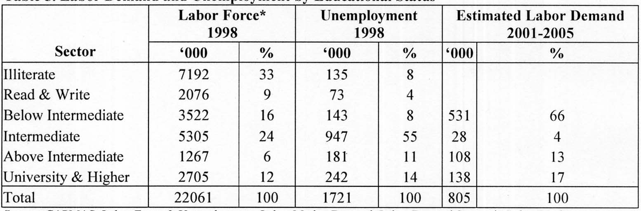

Table 5. Labor Demand and Unemployment by Educational Status [4]

Fig. 3 shows the evolution of enrollment in education at different levels as well as the unemployment rates corresponding to each level in 1986 and 1996. These data clearly shows that education enrollment increased at all levels between 1986 and 1996, especially at the level of higher education. At the same time, official unemployment rates declined across board, especially for those with primary education.

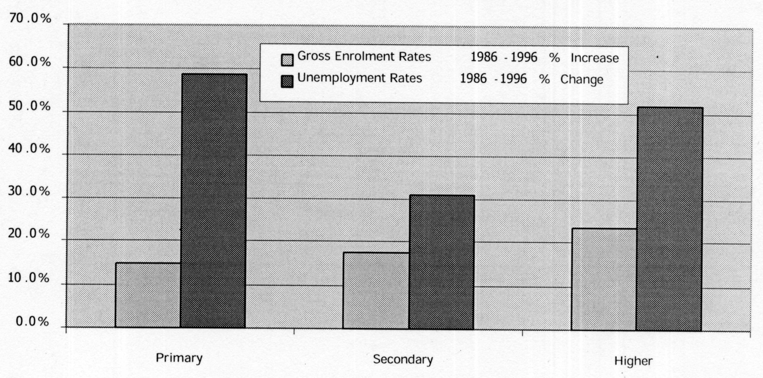

Fig. 3. Evolution of Enrollment and Unemployment
in Egypt (1986 and 1996) [4]

Based on Table 5 and Fig. 3, not only is the education system producing the wrong mix, but also the wrong quality [4]. Training is one way of compensating for these deficiencies, but that too is in need of significant reforms (UNDP-2001). The answer to the question “why is education not delivering ?” was addressed in [4] and the proposed solution was to align incentives the supply side, the demand side, and to correct for market failure.

2.2. Producing a Better Student Mix:
Based on the above, the author finds that the market demand is in mismatch with the existing mix of graduates; also the existing quality of education does produce graduates who can create new demand. The author finds that there are two solutions to break this vicious circle:
(1) Changing the mix of students at different educational stages with the intention of
teaching the skills necessary for these students to meet market demands after
graduation and upgrade the existing production to the level of exportation.
(2) Improving the quality of education at all stages with the intention of increasing the
skills necessary for these students after graduation to create new jobs and products
and establish added-value to Egyptian exports.

3. Recognition of R&D for Evaluation of University Faculty:

Currently, college professors are evaluated basically based on their published research in journals and conferences. The author proposes that industrial R&D should count, in part, in the evaluation process. For example, 20% of the publications could be allowed to be industry reports than theoretical research. This is an example for aligning the incentives of faculty and industry.

4. Collaboration with Technologically-Advanced Countries and Expatriate
Egyptians:

An example of this approach is the “US-Egypt Partnership for Economic Growth and Development” [18]. Better utilization of Expatriate-Egyptians in technological fields is recommended as in [19].

5. Strong Support for R&D:

Examples of R&D support are given in [19]. An example of Israel is detailed in [20].
The author realizes that previous Egyptian Governments gave priority to labor-intensive industries over technology-intensive industries in order to solve serious unemployment problems. On the other hand, technology-intensive industries require several years of accumulated experiences in design, development, manufacturing, testing, etc., before they would grow to adequate international levels suitable for exportation.

Therefore the seeds of technology-intensive industries should be implanted soon to increase the industrial share in the overall local economy, which is currently a service-dominated economy. The conflict between the urgency of high-tech industries and the need for employment in labor-intensive industries should be solved by implementing creative yet non-expensive ideas, which includes incorporating serious structural R&D changes at the factory level, the sector level of a particular industry, as well as the highest management levels in the government.

V. CONCLUSIONS

The paper addressed many educational and training issues which are prerequisites for having science and technology play a pivotal role in the future of Egypt in the 21st century. The paper exemplifies the strong links between 3 areas of development in Egypt namely, education, industry, and economics. Based on the author’s research as well as that of others with economics background, the author concluded in [1] that a strong economy requires a strong industry which emphasizes the 3 goals: volume, diversity, and added value.

In this paper, the author expanded the utilization of the same goals to the areas of education and training. The author’s main theory in this paper is that the 3 magic words
(volume, diversity, and added-value) should constitute the corner stones of education, industry, and economy; they also should be invoked to streamline the relationships among these fields of life. Indeed, the 3 magic words should be the main agenda of Egypt in the 21st century ! Special attention should be paid to the following issues in order for Egypt to have a better future: abolishing illiteracy, increasing the student numbers, changing the student mix, changing curricula, abolishing the science-humanity split, diversifying courses and vocational training, creating industry-school partnerships, instituting project work in the curricula at all educational levels, promoting industrial R&D among university faculty, promoting state and public support for R&D, and
targeted collaboration with technologically-advanced countries and expatriate Egyptians. R&D should be regarded as a national project for the advancement of Egypt.

VI. REFERENCES

[1] M. F. Wagdy, “Egyptian Economy: Problems and Technology-Driven
Development”, Conference CD-ROM Proceedings of the Biannual Conference of the
Association of Egyptian-American Scholars (AEAS), George Washington
University, Washington, DC., 10 pages, May 22-23, 2004.
[2] Information and Decision Support Center (IDSC), Cabinet of Ministers, Cairo,
Egypt, “http://www.idsc.gov.eg/MainIssues/issues_indicator_xml.asp?”.
[3] Educational Attainment and Enrollment around the World, World Bank, Data on
Egypt, “http://www.worldbank.org/research/projects/edattain/
Profiles/egy4/at1.htm”.
[4] “The Paradox of Education and Unemployment in Egypt”, Ahmed Galal, The
Egyptian Center for Economic Studies (ECES), March 2002. Web-Site:
“http://www.worldbank.org/mdf/mdf4/papers/galal.pdf”.
[5] Summary Education Profile: Arab Republic of Egypt, “http://devdata.worldbank.org/
edstats/SummaryEducationProfiles/CountryData/GetShowData.asp?”.
[6] World Bank, Data on Egypt, “http://www.worldbank.org”.
[7] “Secondary Education Reforms in Egypt: Rectifying Inequality of Educational and
Employment Opportunities”, “http://www.ginie.org/cstudies/egypt/cs-egypt.htm”.
[8] “Humanities on the Top”, Al-Ahram Egyptian Newspapers, April 2004.
[9] “While Applying to Colleges: The Escape from The Scientific Section is Not a
Solution”, Al-Ahram Egyptian Newspapers, April 3, 2004.
[10] “The Problem is in Misconceptions”, Al-Ahram Egyptian Newspapers, April 2004.
[11] “The Student Escape from Science to Humanities has Reasons that Urgently Need to
be Cured”, Report by the Supreme Council of Universities, October Magazine, page
52, January 11, 2004.
[12] “Rethinking Higher Education”, October 2004,
“http://www.businesstodayegypt.com/article.aspx?ArticleID=2385”.
[13] “Companies Steer New K-12 Courses”, pp. 27-33, IEEE Spectrum, April 1998.
[14] “National Technical and Vocational Education and Training in Egypt”,
“http://www.ntvet.com/Eg_Doc/birth_idea.asp”.
[15] “Proactive Higher Education for High Technology – Israel: A Special Report”, pp.
39-42, IEEE Spectrum, May 1998.
[16] The Ministry of Industry and Technological Development, Web-Site:
“http://www.mitd.gov/Tech_Center/tech_cent.htm”.
[17] “What Makes a Good School – Special Report”, Time Magazine, October 27, 1997.
[18] “Subcommittee IV: Education and Human Resource Development“, US-Egypt
Partnership for Economic Growth and Development,
“http://www.moe.edu/english/subcomm/subcommittee_iv.html”.
[19] M. F. Wagdy, "Can Egypt Become An Electronics Tiger ?", Conference Proceedings
of the Biannual Conference of the Association of Egyptian-American Scholars
(AEAS), Santa Ana, CA, 8 pages, October 17-19, 1997.
[20] “A High-Tech Haven – Special Report: Israel”, pp. 23-32, IEEE Spectrum, May
1998.

